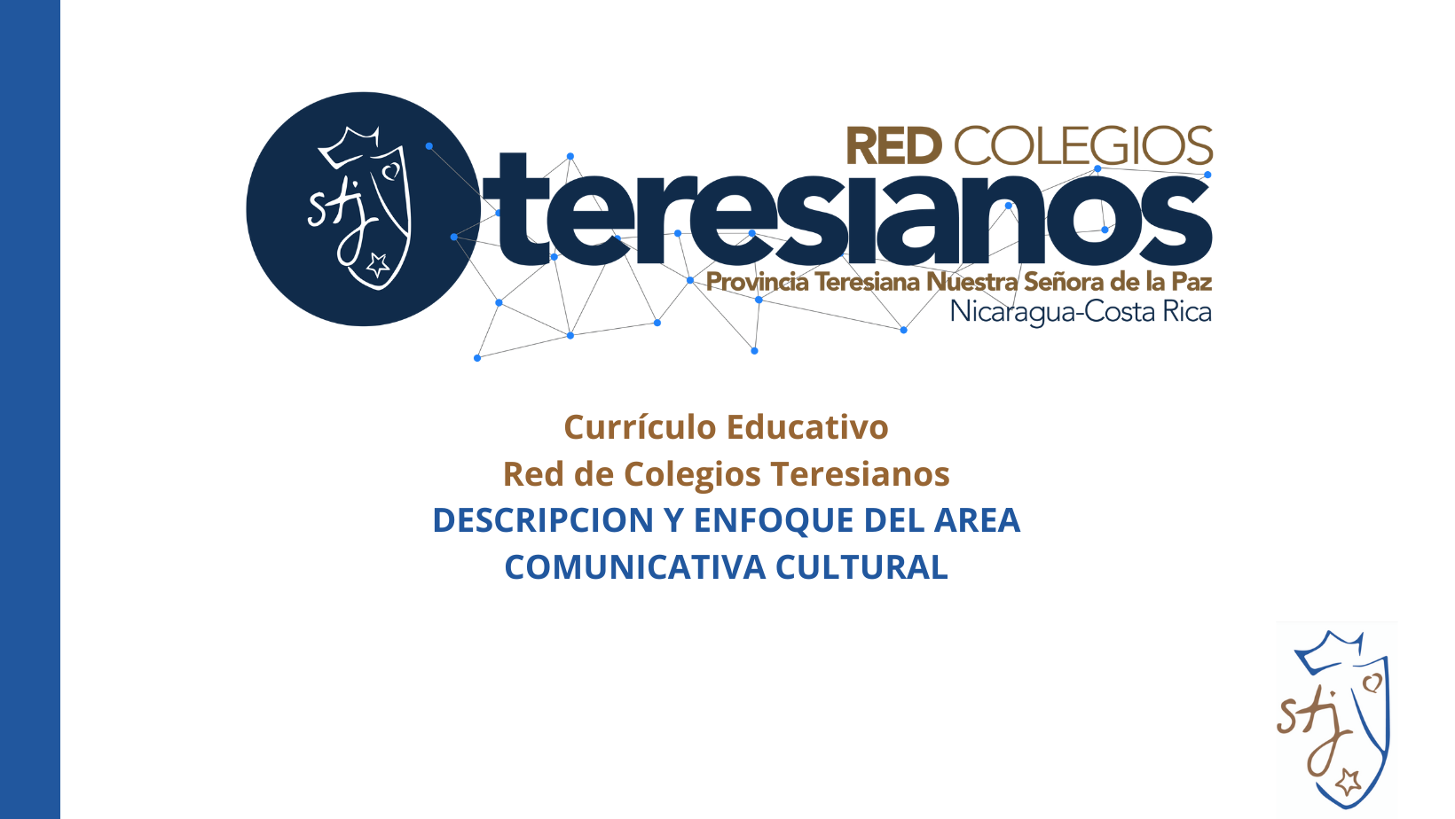

ÁREA
COMUNICATIVA CULTURAL - LANGUAGE ARTS
PROGRAMA BILINGÜE

“Language Arts” is a broad term that refers to all the components of both written and spoken language, used to express thoughts and ideas. It aims at developing the students’ comprehension and capacity for use of written and oral language. In other words, it helps improve students’ understanding of and ability for reading, writing, listening, and speaking. The goal of language arts is to be able to use a language proficiently in order to communicate an idea.

Language arts includes the four main components of Listening, Reading, Speaking, and Writing. Literature study explores theme and form through drama, poetry, novel, myth, fable, and short stories focusing on character analysis, plot, theme, and other literary elements. As an art form, Literature can also include works in various non-fiction genres, such as biography, diaries, memoirs, letters, and essays. In addition, conventions of traditional grammar, such as sentence and paragraph structure are stressed so that students develop writing skills. A complete language arts curriculum should also include spelling, handwriting, vocabulary, composition, and public speaking.

It is important to acknowledge that in our classrooms we do not have native speakers, but English Language Learners (ELLs). In the bilingual program, our students are learning to read, write, and speak in both languages, English and Spanish. ELLs are simultaneously building oral proficiency, writing skills, and content knowledge- and it requires that teachers provide additional supports, such as learning platforms and language learning strategies. Plus, in the lower grades an ESL program is offered for students who need to improve their language skills.

STRANDS
STRAND: ORAL COMMUNICATION
General Skills | Skill 1 | Skill 2 | Skill 3 | OBJECTIVES
General Skills | Participate effectively in a range of conversations and collaborations with diverse partners, building on others’ ideas and expressing their own clearly and persuasively. | Adapt speech to a variety of contexts and communicative tasks, demonstrating command of formal English when indicated or appropriate. | Present information, findings, and supporting evidence to express information, ideas, and feelings using different formats and media. | Communicate effectively in formal and informal conversations building on others´ ideas demonstrating advance command of English. | General Objective
Stage V (10° - 11°) | Participate in conversations by posing and responding to questions that probe reasoning and evidence; ensure a hearing for a full range of positions on a topic or issue; clarify, verify, or challenge ideas and conclusions. | Use accurate general academic and domain-specific words and phrases, sufficient for reading, writing, speaking, and listening at the college and career readiness level; demonstrate independence in gathering vocabulary knowledge when considering a word or phrase important to comprehension or expression. | Present information, findings, and supporting evidence clearly, concisely, and logically such that listeners can follow the line of reasoning and the organization, development, substance, and style are appropriate to purpose, audience, and task. | Present information, findings, and supporting evidence clearly, concisely and logically (using appropriate eye contact, adequate volume, and clear pronunciation) such that listeners can follow the line of reasoning and the organization, development, substance, and style are appropriate to purpose. | Objectives by Stage
Stage IV (7° - 9°) | Prepare for and participate effectively in a range of conversations and collaborations with diverse partners, building on others[ ideas and expressing their own clearly and persuasively. | Present information, findings, and supporting evidence such that listeners can follow the line of reasoning and the organization, development, and style are appropriate to task, purpose and audience. | Present claims and findings, emphasizing salient points in a focused, coherent manner with pertinent descriptions, facts, details, and examples. | Integrate multiple sources and evaluate information presented in diverse media and formats, including visually, quantitatively, and orally. | Objectives by Stage
Stage III (4° - 6°) | Pose and respond to specific questions by making comments that contribute to the discussion and elaborating on the remarks of others. | Differentiate between contexts that call for formal English and situations where informal discourse is appropriate. | Report on a topic or text or resent an opinion, sequencing ideas logically and using appropriate facts, pertinent descriptions, facts, and details to accentuate main ideas or themes; use appropriate eye contact, adequate volume, and clear pronunciation. | Actively and effectively participate in a range of collaborative discussions with diverse partners, building on others’ ideas and expressing their own clearly and persuasively. | Objectives by Stage
Stage II (1° - 3°) | Participate in collaborative discussion building their own ideas, stay on topic, and ask and answer questions to check understanding. | Use words and phrases (acquired through conversations, reading and being read to) to speak in complete sentences when reporting on a topic or text to provide requested detail or clarification. | Report on a topic or text, tell a story, or recount  an experience with appropriate facts and relevant, descriptive details, speaking clearly at an understandable pace. | Actively and effectively participate in a range of collaborative discussions with diverse partners, building on others’ ideas and expressing their own clearly and persuasively. | Objectives by Stage

STRAND: WRITTEN COMMUNICATION
General Skills | Skill 1 | Skill 2 | Skill 3 | Skill 4 | OBJECTIVES
General Skills | Write a variety of texts to examine and convey complex ideas and information clearly and accurately with appropriate organization, and style to task, purpose, and audience. | Develop and strengthen writing by planning, revising, editing, rewriting or typing. (Review, Revision, and Editing of Writing and Representation) the process of writing | Conduct short as well as more sustained research projects demonstrating understanding of the subject under investigation and integrate the information while avoiding plagiarism. | Develop a routine of writing over extended time frames (time for research, reflection, and revision) and shorter time frames (a single sitting or a day or two) for a range of tasks, purposes, and audience. | Write a variety of complex texts following the process of writing and conducting research projects to express his/her own ideas and opinions routinely. | General Objective
Stage V (10° - 11°) | Write arguments to support claims in an analysis of substantive topics or texts, using valid reasoning and relevant and sufficient evidence. | Produce and strengthen comprehensible writing as needed by planning, editing, or trying a new approach. | Conduct research projects to answer a question , drawing on several sources and generating additional related, focused questions that allow for multiple avenues of exploration. | Write routinely over extended time frames for a range of tasks, purposes, and audiences to support analysis, reflection, and research. | Write arguments to support claims creating an organization that logically sequences claim(s), counterclaims, reasons, and evidence. | Objectives by Stage
Stage IV (7° - 9°) | Write texts to examine and convey complex ideas, concepts, and information clearly and accurately through the effective selection, organization, and analysis of content. | Produce clear and coherent writing in which the development, organization, and style are appropriate to task, purpose, and audience. | Gather relevant information to conduct research projects from multiple sources using search terms effectively, assess credibility and accuracy of each source. | Write routinely over extended time frames for a range of tasks, purposes, and audiences. | Write claim(s), acknowledge alternate or opposing claims, and organize the reasons and evidence logically through effective organization and analysis of content. | Objectives by Stage
Stage III (4° - 6°) | Write compositions, using organizational structures  with ideas logically grouped to support facts and points of view with reasons and information. | Develop and strengthen writing as needed by  planning, revising, editing, rewriting, or trying a new approach to produce clear and coherent writing appropriate to task, purpose, and audience. | Conduct guided research projects that use several sources to summarize or paraphrase information of different aspects of a topic, and provide a list of sources. | Write routinely over extended time frames (time for research, reflection, and revision) and shorter time frames (a single sitting or a day or two) for a range of discipline-specific tasks, purposes, and audiences. | Write narratives, opinions, informative/explanatory/argumentative texts on topics to demonstrate an adequate application of the skills in all aspects of language from vocabulary and syntax to the organization of the ideas. | Objectives by Stage
Stage II (1° - 3°) | Write short compositions, giving opinions and describing informative and explanatory texts | With guidance and support from adults,  produce and develop strengthen writing as needed by planning, revising, and editing. | Conduct short research projects that build  knowledge about a topic. | Write routinely  for specific tasks, purposes, and audiences. | Write opinion pieces on topics appropriate to task, purpose, and audience. | Objectives by Stage

STRAND: READING COMPREHENSION
General Skills | Skill 1 | Skill 2 | Skill 3 | OBJECTIVES
General Skills | Foundational Skills:  Read with sufficient accuracy and fluency to support comprehension | Read and comprehend complex literary and informational texts in diverse formats and media independently and proficiently; analyzing the key details, structure, and format of the text. | Reading for pleasure  Read different kinds of fiction and nonfiction texts selected by the students with the primary purpose of enjoyment | Read comprehensively,  independently and proficiently to evaluate and discuss the theme and message of a variety of texts in diverse formats and media. | General Objective
Stage V (10° - 11°) | Read with sufficient accuracy and fluency to support comprehension | Read and evaluate complex literary and informational texts independently and proficiently to analyze multiple interpretations of various topics and themes. | Read different fiction and nonfiction kinds of texts selected by the students with the primary purpose of enjoyment | Read and evaluate complex literary and informational texts using relevant evidence to support their own point of view ( the content and build their worldview.) | Objectives by Stage
Stage IV (7° - 9°) | Read with sufficient accuracy and fluency to support comprehension | Read closely to analyze what the text says explicitly and to make logical inferences from it; cite specific textual evidence to support conclusions drawn from the text. | Read regularly to enjoy and read prose and poetry. (literary devices) | Read closely, regularly and fluently different kinds of texts to analyze and discuss what they say explicitly and support conclusions drawn from the texts. | Objectives by Stage
Stage III (4° - 6°) | Know and apply grade-level word analysis skills in decoding words to read with sufficient accuracy and fluency to support comprehension. | Read closely to determine what the text says explicitly and to make logical inferences from it by analyzing the central theme, the plot, structure of the text, personal opinions and judgements. | Read frequently and independently, non fiction stories, dramas and poetry for enjoyment. | Read grade- level texts with sufficient accuracy and fluency to determine and analyze the theme and its central message from the explicit and inferred details. | Objectives by Stage
Stage II (1° - 3°) | Demonstrate understanding and production of basic features of print,word recognition,decode and spelled words to read with accuracy and fluency grade-level texts. | Read closely to understand and interpret what the text says explicitly by recounting the stories, and describing the main characters, plot, sequence of events, and their point of view. | Read regularly to enjoy and learn about stories, folktales, legends,fables, fantasy, realistic fiction, myth and nonfiction. | Read regularly grade- level texts with accuracy and fluency to distinguish literary elements to appraise a clear point of view from texts. | Objectives by Stage

STRAND: LANGUAGE CONVENTION
General Skills | Skill 1 | Skill 2 | Skill 3 | OBJECTIVES
General Skills | Demonstrate command of the conventions of standard English grammar and usage  when writing or speaking. | Acquire and use accurately a range of general academic and domain‐specific words and phrases sufficient for reading, writing, speaking, and listening | Apply knowledge of language to understand how language functions in different contexts, to make effective choices for meaning or style, and to comprehend more fully when reading or listening. | Demonstrate command of advanced English using accurate vocabulary, and grammar conventions adapting language to the context and interaction. | General Objective
Stage V (10° - 11°) | Demonstrate command of the correct use of grammar to convey specific meanings and add variety and interest to writing or speaking for academic purposes. | Acquire and use accurately a range of academic and domain specific words using context (e.g., the overall meaning of a sentence, paragraph, or text; a word's position or function in a sentence) as a clue to the meaning of a word or phrase. | Apply an understanding of syntax to the study of complex texts when reading, building on others' ideas and expressing their own clearly. | Demonstrate independence in acquiring and using mechanics and vocabulary knowledge for reading, writing, speaking, and listening. | Objectives by Stage
Stage IV (7° - 9°) | Demonstrate command of the conventions of standard English when writing expository essays that describe, narrate, and compare and contrast. | Determine and clarify the meaning of unknown and multiple-meaning words and phrases by using context clues, analyzing meaningful word parts, and consulting general and specialized reference materials. | Use and explain knowledge of language and its conventions when writing, speaking, reading, or listening. | Understand and explain the correct use of grammar, punctuation and vocabulary for effective communication in speaking, reading and writing. | Objectives by Stage
Stage III (4° - 6°) | Demonstrate command of the conventions of standard English  to express, listen or write opinions, concepts, emotions or situations using the correct punctuation. | Determine or clarify the meaning of unknown and  multiple-meaning words to aid comprehension or expression using reference materials. | Demonstrate command of the writing conventions of standard English to describe, argue, and inquire when writing, speaking, reading, or listening. | Understand and apply the correct use of grammar, punctuation and vocabulary for effective communication in speaking, reading and writing. | Objectives by Stage
Stage II (1° - 3°) | Articulate and use command of the conventions of standard English to create complete sentences when writing and speaking using the right punctuation. | Determine and use the meaning of unknown words, sight words, phrases and sentences using different strategies to build on ideas. | Increase code knowledge of language and its conventions to express and understand meaning and purpose when communicating in writing and speaking. | Distinguish and show the correct use of English grammar, vocabulary and language according to the context when speaking, writing, reading, and listening. | Objectives by Stage

